**Linux Basic Commands Assignment**

**Assignment Part-3**

Playing with files

1. Create a file like **nano file1.txt**

o Edit some data and then save the file

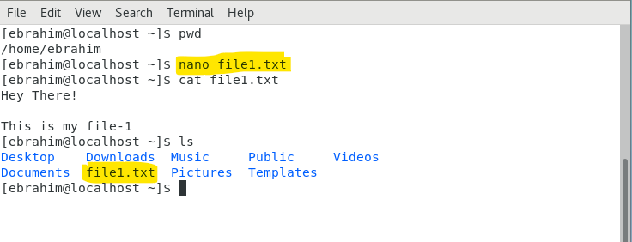

1. Now we will copy data from file1 to new file2   
   o cp file1.txt file2.txt   
   o Then see the output of file2.txt, cat file2.txt

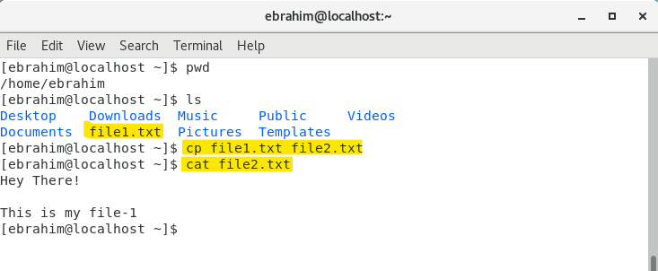

1. Now we will move the file2.txt to new folder /home   
   o mv file2.txt /home   
   o Then go to home directory and check ls, file exits or not?  
     
   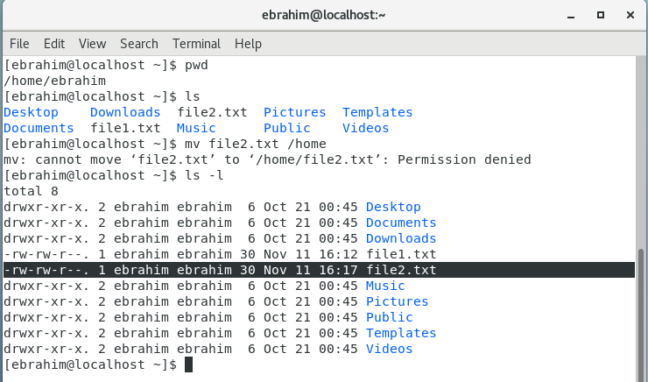

Permission denied error shown. To clear I used chmod and moved it, yet the same error.

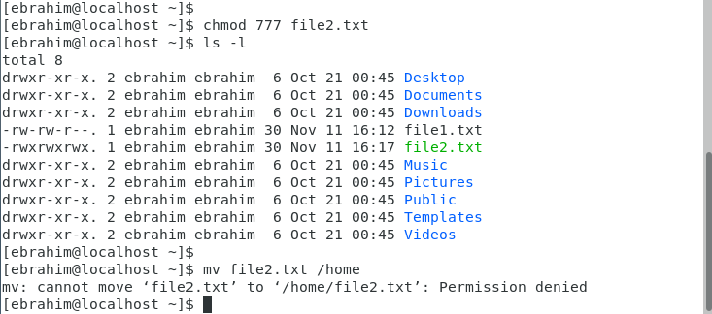

File2.txt successfully moved when used root access for the permission issue.

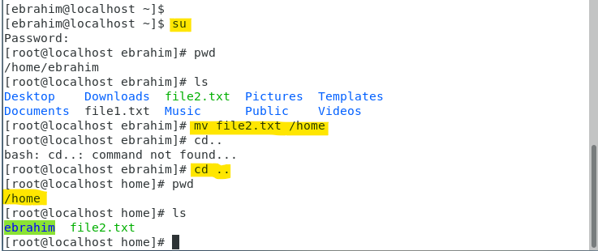

1. Then we create a new file3.txt and file4.txt in home directory and add content in it.   
   o Now do echo “Hello I am newline” > file3.txt and provide the output of file3.txt  
     
   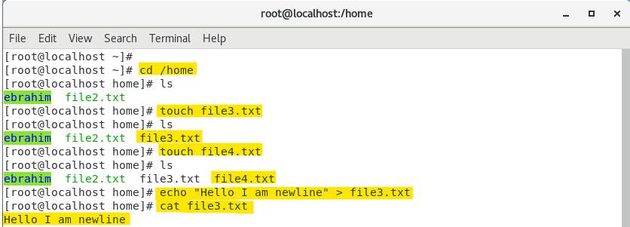

o Now do echo “Hello I am newline” >> file4.txt and provide the output of file4.txt



o Tell the different between both step you follow and the reason behind it.  
  
Using “**>**” writes the data in the file. However, when used again to add new data to the same file. It will replace the previous data and only hold the new data.

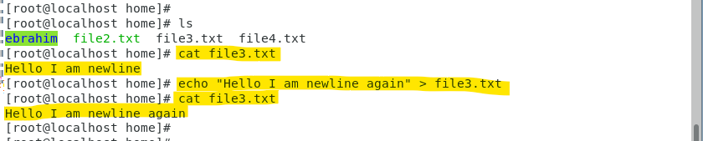

Using “**>>**” writes the data in the file. But whereas in this case, it will append the newly added data with the previous data in the file.

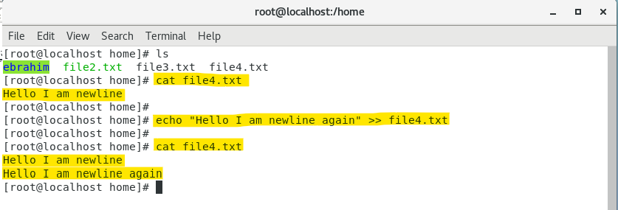

1. For remove a file or directory you can use the below two commands   
     
   o To delete a file – **rm <any filename>**  
     
   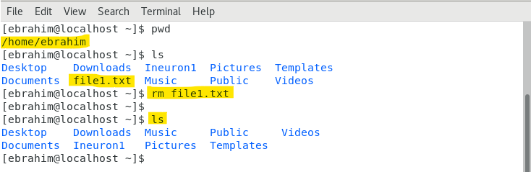

o To delete a file – **rmdir <any directoryname>**

